Order Of Service

Singing: Psalm 119a—CW page 109

Reading: Psalm 53

Opening Hymn: TLH 227

Reading: Acts 5:1-11

Request Hymn: CW Supplement 748

Reading: John 12:27-36a

Sermon Hymn: TLH 236

Sermon Text: Song Of Solomon 8:2-4

My Mother’s House

Prayer

The Apostles’ Creed, TLH page 12

Holy Communion

The Lord's Prayer

The Blessing

Closing Hymn: TLH 234

* * * * * * * * * * *

Koinonia Hour



Garnished The Heavens

Water
Of
Life

3 September 2017

W A T E R O F L I F E

Independent Christian Church—Conservative Lutheran Doctrine

Worship Service: 9:30 a.m. Bible Study: 10:45 a.m.

Larry Cooper, Pastor E-Mail address:
111 N. Ridge Road lcooper@wateroflife.cc
Coon Valley, WI 54623 Web Site:
Phone: (608) 452-2105 www.wateroflife.cc

* * * * * * * * * * * * * * * * * * * * * * * * * * *

Sermon Text: Song Of Solomon 8:2-4

My Mother’s House

* * * * * * * * * * * * * * * * * * * * * * * * * * *

Song of Solomon 8:2 I would lead thee, and bring thee into my mother's house, who would instruct me: I would cause thee to drink of spiced wine of the juice of my pomegranate.
:3 His left hand should be under my head, and his right hand should embrace me.
:4 I charge you, O daughters of Jerusalem, that ye stir not up, nor awake my love, until he please.

Related Readings: Luke 15:8-10

8 Either what woman having ten pieces of silver, if she lose one piece, doth not light a candle, and sweep the house, and seek diligently till she find it?
9 And when she hath found it, she calleth her friends and her neighbours together, saying, Rejoice with me; for I have found the piece which I had lost.
10 Likewise, I say unto you, there is joy in the presence of the angels of God over one sinner that repenteth.

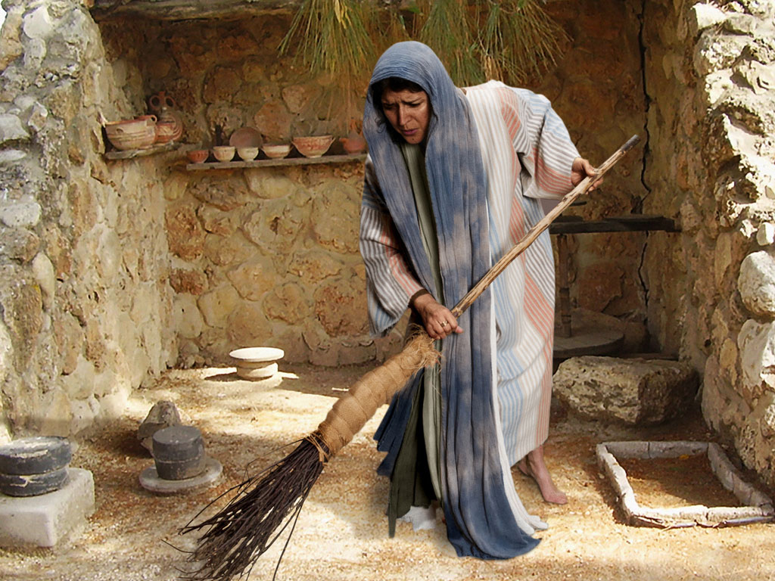

Context of Luke 15

:3-7 The Shepherd seeks for his lost sheep.

:8-10 The Woman seeks for her lost coin

:11-32 The Father seeks for his lost son.

